

**AMERICAN INTERNATIONAL UNIVERSITY–BANGLADESH (AIUB)**

**FACULTY OF SCIENCE & TECHNOLOGY**

**DEPARTMENT OF PHYSICS**

**PHYSICS 1 LAB**

**Spring 2021-2022**

**Section: B19 ,Group: 03**

**LAB REPORT ON**

**TO DETERMINE THE ACCELERATION DUE TO GRAVITY APPLYING LINEAR LEAST SQUARE REGRESSION METHOD BY USING A SIMPLE PENDULUM**

**Supervised By**

**Md. Saiful Islam**

**Submitted By**

|  |  |  |
| --- | --- | --- |
| Name | ID | Contribution |
| **1. Sha Sultan Sowhan** | **22-47014-1** | Discussion and References |
| **2. Mahmuda Khatun** | **22-47016-1** | Procedure and Experimental Data |
| **3. Farjana Yesmin Opi** | **22-47018-1** | Analysis and Calculation, Result |
| **4. Md. Abu Towsif** | **22-47019-1** | Theory and Apparatus |

Date of Submission: March 02, 2022

**TABLE OF CONTENTS**

|  |  |
| --- | --- |
| **TOPICS** | ***Page no*.** |
| 1. **Title Page** | 1 |
| 1. **Table of Content** | 2 |
| 1. **Theory** | 3,4 |
| 1. **Apparatus** | 5 |
| 1. **Procedure** | 5 |
| 1. **Experimental Data** | 6 |
| 1. **Analysis and Calculation** | 7,8 |
| 1. **Result** | 9 |
| 1. **Discussion** | 9 |
| 1. **References** | 10 |
|  |  |

1. **Theory**

The time period of small-angle oscillation of a simple pendulum (a metal bob attached by a light string and suspended vertically from a fixed support) can be shown to be

T = 2π $\sqrt{\frac{L}{g}}$

where L is the effective length (length from the point of suspension to the center of the bob) and time period (time of one complete oscillation) of a simple pendulum, respectively in a place where the acceleration due to gravity is g.

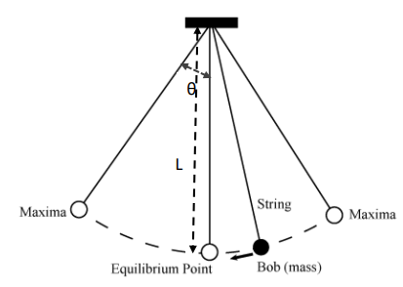

Figure 1: A swinging simple pendulum with an effective length L and amplitude θ

The time period equation of a simple pendulum can be rearranged as,

T2 = L

Comparing this equation with the state line equation that goes through the origin (y = mx) the value of acceleration due to gravity can be determined by

g = $\frac{{4π}^{2}}{m}$

where m is the slope of the T2 vs L graph.

For two types (independent and dependent) of variables x and y = f(x) the linear least square regression method can be used for N number of data points to find the best fitted line (regression line) as the fig. 2 shows.

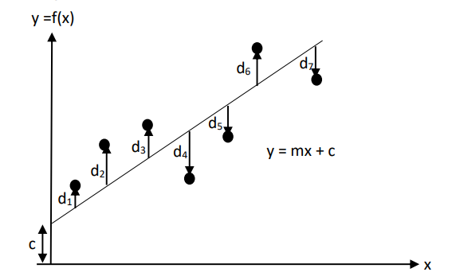

Figure 2: Way to get the best fitted line by finding the minimum value of D = d12 + d22 + d32 + d42 + d52 + d62 + d72 according to the least square regression method. The equation for the best fitted line is y = mx + c, where m is the slope and c is the interception in the y axis. Here the number of data points is taken as N=7.

The formula for determining the slope of the regression line

m = $\frac{\sum_{i}{x_{i}y_{i}-\frac{(\sum_{i}{x_{i })(\sum_{i}{y_{i})}}}{N}}}{\sum_{i}{{x_{i}}^{2}}-\frac{({\sum_{i}{x_{i })}}^{2}}{N}}$ (slope equation)

and intercept c = y̅- m x̅, where x̅ and y̅ are mean value of x and y.

In the slope equation:

∑𝑖 𝑥𝑖 = 𝑥1 + 𝑥2 + 𝑥3 + 𝑥4 + 𝑥5 + 𝑥6 + 𝑥7,

∑𝑖 𝑦𝑖 = 𝑦1 + 𝑦2 + 𝑦3 + 𝑦4 + 𝑦5 + 𝑦6 + 𝑦7,

∑𝑖 𝑥𝑖𝑦𝑖 = 𝑥1𝑦1 + 𝑥2𝑦2 + 𝑥3𝑦3 + 𝑥4𝑦4 + 𝑥5𝑦5 + 𝑥6𝑦6 + 𝑥7𝑦7,

(∑𝑖 𝑥𝑖 ) 2 = (𝑥1 + 𝑥2 + 𝑥3 + 𝑥4 + 𝑥5 + 𝑥6 + 𝑥7 ) 2 ,

∑i 𝑥𝑖 2 = 𝑥12 + 𝑥2 2 + 𝑥3 2 + 𝑥4 2 + 𝑥5 2 + 𝑥6 2+𝑥72

1. **Apparatus**

* Metal bob
* A piece of string
* Stand
* Clamp
* Meter scale and
* Stop watch

1. **Procedure**
2. First of all, we attached a light piece of string with the hook of metal bob. Then we found the length ,L of the pendulum with a meter scale from the point of suspension to the mid-point of the bob.
3. We gave a small angle (less than 10 degrees) swing to the pendulum and found the time period, T. To do it, we measure the total time for 20 oscillation and divide it by 20. Then repeated the procedure for different lengths and record the data in table 1 .
4. After that we found the regression line and from the value of slope found g from the relation: slope=4π2/g.
5. At last we plotted the same graph in Excel and also found the value of g from the equation of the graph
6. **ExperimentalData**

|  |  |  |  |  |  |  |
| --- | --- | --- | --- | --- | --- | --- |
| No.  of  Obs. | Effective Length  L  (cm) | Time for 20 Oscillations  t  (s) | Time period  T = t/20  (s) | T2  (s2) | L2  (cm2) | L.T2  (cm.s2) |
| 1 | 150 | 48.52 | 2.426 | 5.885 | 22500 | 882.75 |
| 2 | 140 | 46.78 | 2.339 | 5.471 | 19600 | 765.94 |
| 3 | 130 | 45.38 | 2.269 | 5.148 | 16900 | 669.24 |
| 4 | 120 | 43.81 | 2.190 | 4.796 | 14400 | 575.52 |
| 5 | 110 | 42.66 | 2.133 | 4.550 | 12100 | 500.5 |
| 6 | 100 | 39.78 | 1.989 | 3.956 | 10000 | 395.6 |
| 7 | 90 | 38.21 | 1.910 | 3.648 | 8100 | 328.32 |
| **∑** | 840 | - | - | 33.454 | 103600 | 4117.87 |

**Table 1** : Time periods T for different lengths L of the simple pendulum

1. **Analysis and Calculation**

|  |  |  |  |  |  |  |  |
| --- | --- | --- | --- | --- | --- | --- | --- |
| N | ∑𝑖 𝑥𝑖 | ∑𝑖 𝑦𝑖 | ∑𝑖 𝑥𝑖𝑦𝑖 | (∑𝑖 𝑥𝑖 )2 | ∑𝑖 𝑥𝑖2 | m | c |
| 7 | 840 | 33.454 | 4117.87 | 705600 | 103600 | 0.369 | 0.351 |
| Equation : y = mx + c  y = 0.0369x + 0.351 | | | | | | | |

**Table 2**: Finding the slope, m and intercept, c by using the linear least square regression method

1. **The value of g using the LLSRM**

m = $\frac{ \sum_{i}{x_{i}y_{i}-\frac{(\sum_{i}{x_{i })(\sum_{i}{y_{i})}}}{N}}}{\sum_{i}{{x_{i}}^{2}}-\frac{({\sum_{i}{x_{i })}}^{2}}{N}}$

= $\frac{4117.87-\frac{840*33.454}{7}}{103600-\frac{705600}{7}}$

= 0.0369

$\overline{x}$ = $\frac{\sum_{i}{x_{i}}}{N}$ = $\frac{840}{7}$ = 120

$\overline{y }$ = $\frac{\sum_{i}{y_{i})}}{N}$ = $\frac{33.454}{7}$ = 4.779

Intercept, c = $\overline{y}-m\overline{x }$ = 0.351

Acceleration due to gravity by LLSRM, g𝐿 = = = 1068.79 cm/s2 = 10.687 m/s2

1. **The value of g from the graph of Excel:**

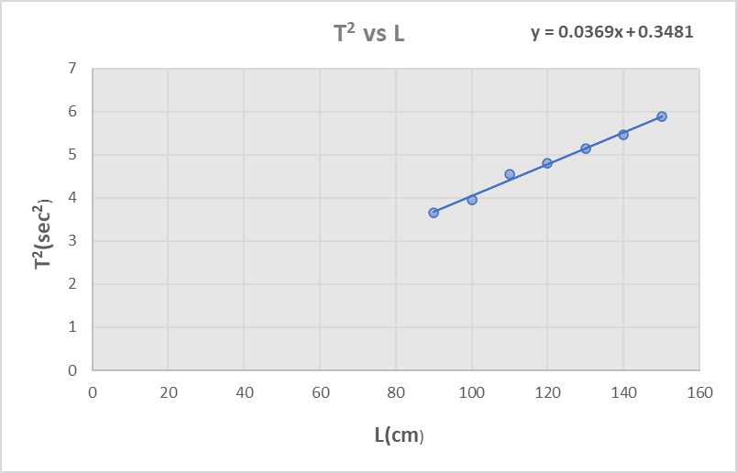

**Figure 3**: Graph of excel

Slope of the regression line, m = 0.0369

Acceleration due to gravity by Excel, 𝑔𝐸 = =  **=** 1068.79 cm/s2 = 10.687 m/s2

1. **Percentage of difference in g between Excel and LLSRM**: $\frac{g_{E \sim } g_{L}}{g_{E}}$ $×$ 100

= $\frac{1068.79 \sim 1068.79 }{1068.79}$ $×$ 100

= 0 %

1. **Result**

|  |  |  |
| --- | --- | --- |
| **Method** | **Value of g (m/s2)** | **Comment** |
| LLSRM | 10.687 m/s2 | The percentage of difference in g between Excel and LLSRM is 0% |
| Excel | 10.687 m/s2 |

1. **Discussion**

We found the value of g (acceleration due to gravity) is 10.687 m.s-2 through LLSRM method as well as 10.787 m.s-2 through the excel graph. We can see that the values are same if we consider three digits after decimal. But we found the values of intercept c different. The value of intercept c is 0.351 through LLARM method where we found 0.3481 in the excel graph.

While measuring the oscillation of the bob, we had to make sure that the bob was moving freely. Sometimes the bob might not move freely because of some frictional problem. Also there might be some error while measuring the bob by slide calipers. We also should make sure that stand was properly straight.

1. **References**

* **Video Links**:
* Simple pendulum:

1. https://www.youtube.com/watch?v=02w9lSii_Hs

2. https://www.youtube.com/watch?v=bJKEN43695k

* LLSRM:

1. https://www.youtube.com/watch?v=0T0z8d0_aY4

2. https://www.youtube.com/watch?v=1C3olrs1CU